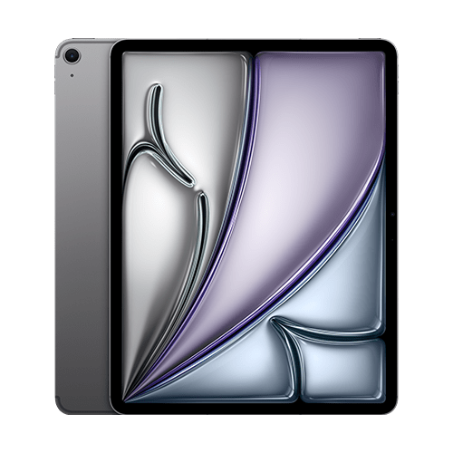

* Apple iPad Air 13
* Processor: Apple M2
* Front Camera: 12 MP
* Rear Camera: 12 MP
* Display: 13 “
* NFC: No
* Colors: Space Gray, Starlight, Purple, Blue
* Operating System: iPadOS 17.5.1

Charging Type: USB Type-C 3.1 Gen2

* SIM: eSIM
* Fingerprint: Yes
* Release Date: 2024, May 15

RAM

8

GB

ROM

1

TB

BATTERY

9705

mAh



+001-28272300-2466-2469



webmaster@cellinfo.com



A-65, ACME Co. ,

Street No. 12,

New York

Ask Me Ltd.